TIGRAY WATER RESOURCES DEVELOPMENT COMMISSION

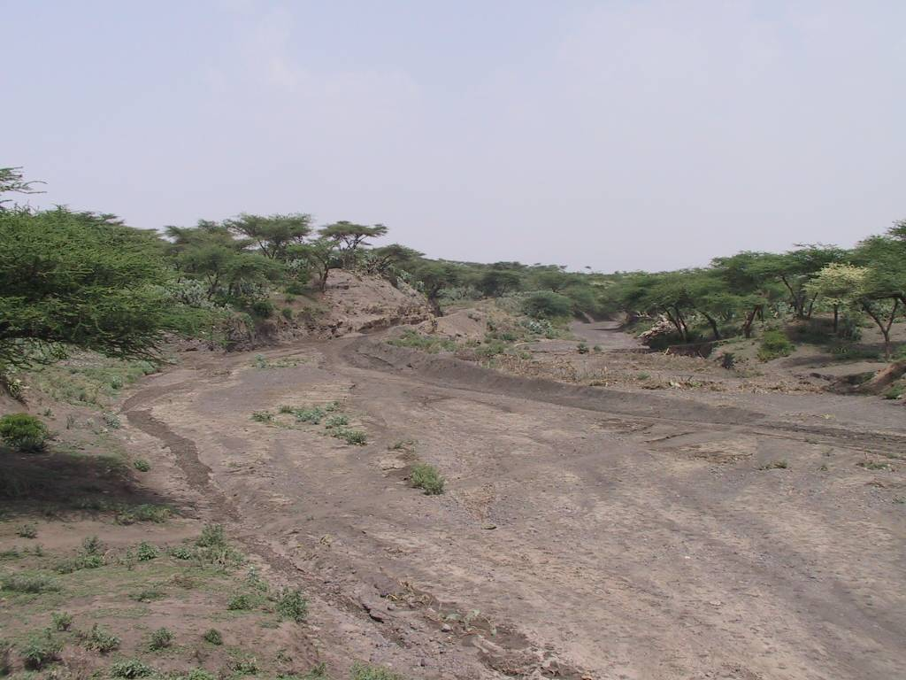

IRRIGATION DEVELOPMENT STUDY AND DESIGN DEPARTMENT

Monitoring and Evaluation
of Spate Irrigation in Tigray

By

Daniel Teka
Tesfa-alem G/Egziabher
Woldemariam G/Hiwot
Alemseged Mekonnen

August, 1997 E.C.
Mekelle

Table of Contents

Page
1.0 INTRODUCTION 1
1.1 GENERAL 1
1.2 BACKGROUND 1
1.3 LIMITATION OF THE MONITORING PROCESS 2
1.4 LOCATION OF THE PROJECT AREA 3
2.0 METHODOLGY 4
3.0 MAJOR PROBLEMS 4
3.1 HARA 4
3.2 TIRKIE 6
3.3 BEYRU 10
3.4 BURKA 11
4.0 CONCLUSION AND RECOMMENDATION 13

List of Figures

Page

Figure 1: Rough sketch showing the condition at the first inverted Syphon 5
Figure 2: Sketch showing the offtake angle claimed by farmers at Hara 6
Figure 3: Diversion Headwork without the provision of divide wall at Tirkie. 6
Figure 4: Provision of wider pier in front of the head regulator at Tirkie. 7
Figure 5: Side wall & D/S apron scouring at Tirkie. 7
Figure 6: Blocked sluice gates at Tirkie. 8
Figure 7: Sedimentation entry to canal from the nearby command area. 8
Figure 8: Breaching of the main canal at points where there is no turnout provision. 9
Figure 9: Rough sketch showing the offtake angle claimed by farmers at Tirkie 9
Figure 10: Scouring around de-silting basin flushing outlet at Burka. 10

At present, the area covered by irrigation is insignificant compared to the irrigable potential. Sufficient food has to be produced to meet the requirements of a fast growing population and to ensure food security at household level. Furthermore, small, medium, and large-scale irrigation schemes need to be developed in order to ensure reliable agricultural production. This is needed to cater for domestic consumption and externally marketable surplus that would earn the country foreign exchange.

Kinfe Abraham

INTRODUCTION

1.1 GENERAL

The essence of small scale irrigation development using small scale diversion works essentially has the major purpose of increasing agricultural production per unit of arable land. The use of low cost and appropriate technology based on the wilful participation of the beneficiaries in the construction of the schemes is the corner-stone of these projects in terms of reducing cost, assuring sustainability and regional policy strategies.

It is believed that irrigation is a potential means to effectively utilize the agricultural potential of this area. The dominant agriculture practised in this area is rained agriculture, mainly supplemented by spate irrigation. These projects are considered to be single season irrigation projects which entirely depend on the surface run off generated at the high lands of the valley. The spate irrigation design method is purely conventional and for this reason further design procedure is best be supported by feed back obtained from already on operational schemes and traditionally practiced schemes.

1.2 BACKGROUND

In all the spate irrigation schemes being observed, the farmers have positive attitude towards the projects. The traditional flood harvesting structures are so simple that they are washed away by strong floods. The farmers are used to construct the structures after every heavy flood passing. Therefore, the farmers are very happy seeing permanent structures constructed there. However, they have complaints on the design of the structures. The farmers divert the runoff at several points at a time. Moreover, the canal sizes of the traditional schemes are larger than the ones in the upgraded system. This is especially true in Burka spate irrigation scheme. So the farmers are suspicious whether the improved schemes could irrigate the intended command area. The farmers strongly emphasizes that their complaints are not considered during the construction phase. For example, in Hara and Tirke spate irrigation schemes, the off take structures are Box and pipe culverts respectively. Nevertheless, the farmers are demanding open off take. Since there is high sedimentation with heavy boulders in the area, the off take is clogged easily. Therefore, the off take and the size of the main canals of these schemes should be revised. Although not completely, the design of Beyru and Burka has incorporated the demand of the farmers to some extent.

The main aim of this paper is, therefore,
- to point out the main problems encountered during the operation of the first fully operational spate irrigation schemes designed and constructed by the Commission, Hara, Tirkie, Beyru and Burka.
- to evaluate the performance of these schemes and monitor traditional spate irrigation practices,
- to monitor surface runoff and thereby prepare some hypothetical hydrograph (Fokissa, Trkie and Burka) and
- foreward some practical design solutions and/or considerations to be made during feasibility study phase.

1.3 LIMITATION OF THE MONITORING PROCESS

The majority of monitoring works were conducted in the absence of runoff in the desired amount. Most of the runoff events observed during the monitoring works are in the order of magnitude of less than 150LPS & all occurred during night time. Due to this the team couldn’t get reliable information on measuring runoff besides some fears of the users were not proved on the ground like work quality, canal and off take complaints.

1.4 LOCATION OF THE PROJECT AREA

- HARA
Administrative Location

Zone:
Woreda:
Southern
Alamata

Geographical Location

Latitude:
Longitude:
Altitude:
1374450N
561400E
1540masl

- TRKIE
Administrative Location

Zone:
Woreda:
Tabia:
Southern
Alamata
La’elay Dayu

Geographical Location

Latitude:
Longitude:
Altitude:
1385928 N
564807 E
1609masl

- BEYRU
Administrative Location

Zone:
Woreda:
Tabia:
Southern
Mehoni
Beyru

Geographical Location

Latitude:
Longitude:
Altitude:

- BURKA
Administrative Location

Zone:
Woreda:
Tabia:
Southern
Mehoni

Geographical Location

Latitude:
Longitude:
Altitude:

2.0 METHODOLGY

To assess the operation and functionality of constructed schemes as well as operations of traditionally irrigated schemes, field observation coupled with primary data obtained by interviewing beneficiary and administrative officials at Woreda as well as Tabia level have been conducted.

3.0 MAJOR PROBLEMS

The major problems observed for this purpose are grouped as Operational, construction, Design and/or claims made by the farmers. When we say operational it is to mean problems that arise due to miss use or inappropriate handling of system. Construction problems are those that arise due to improper/incomplete construction procedure. Design problems to mean that problems that arise due to the fact that the design does not take in to account actual field condition into consideration. Claims made by the farmers include traditional practices that the farmers want to be also included in the design but yet not included.

3.1 HARA

The scheme has been handed over to the beneficiaries at the end of 1996 E.C. although it started operation since 1995 E.C. The scheme has encountered the following main problem:
DESIGN PROBLEMS
- number and location of turnouts.
- absence of divide wall on the U/S side of the weir, so that a pocket can not be created in front of the head regulator that facilitates diversion of silt free runoff to the main canal,

- provision of no manholes for the inverted Syphons. Due to this the pipes can not be cleared easily and hence runoff that is diverted from the headwork can not pass through it. The farmers have proposed an earthen ditch on the U/S of the inverted Syphon section to bypass the flow. As the same time the farmers has constructed a new traditional diversion point to divert the runoff to the constructed canal system on the left side (facing D/S).
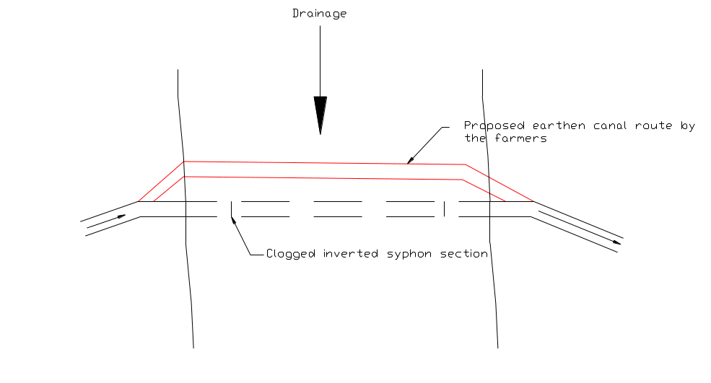
Figure 1: Rough sketch showing the condition at the first inverted Syphon

- provision of no flushing device at the de-silting basins. The trapped sediment in the de-silting basin is so huge that it is difficult to clean it manually. So provision of self cleaning device is inevitable.
- The designed canal bed slope as compared to canal bed slopes in the traditional spate irrigation system seems flatter and hence subjected to siltation.
CONSTRUCTION PROBLEM
- leakage through sluice gate grooves. This leads to loss of water through the gate during times of minimum flow. The farmers have solved this problem by not removing/flushing the sediment deposited behind the sluice gate.
OPERATIONAL PROBLEMS
- the accumulation of high silt load at the head regulator,
- sediment accumulated in the de-silting as well as conveyance canals are not removed regularly
- Hence the beneficiaries are forced to construct traditional diversion points especially for the left side command area (facing D/S).
CLAIMS MADE BY THE FARMERS
- Taking the existing operation of gates into account, the beneficiaries in this project are complaining that the designed angle of diversion, which is at 90o; need to be at some lower angle of diversion so that the incoming runoff can be diverted to the offtaking canals without the need to create sluice pocket to trap the sediment.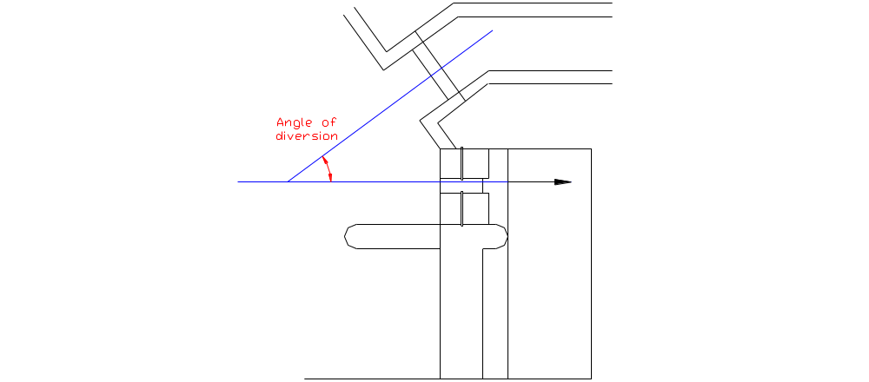
Figure 2: Sketch showing the offtake angle claimed by farmers at Hara

- They still need the head regulator to be an open channel in stead of box culvert.

3.2 TIRKIE

The construction of this scheme is completed and handed over to the beneficiaries in 1996EC. It is designed to irrigate 380Ha of land.
DESIGN PROBLEMS
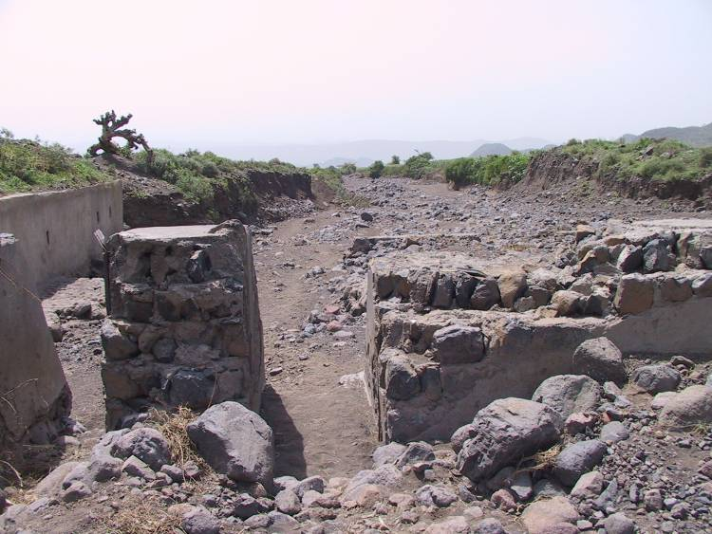
- absence of divide wall so that a pocket can not be created in front of the head regulator that facilitates diversion of silt free runoff to the main canal,

Figure 3: Diversion Headwork without the provision of divide wall at Tirkie.
- wider pier thickness is provided between the first sluice gate and the side wall there by blocks the silt accumulated in front of the off take from easily flushing out through the sluice (see Fig. ),
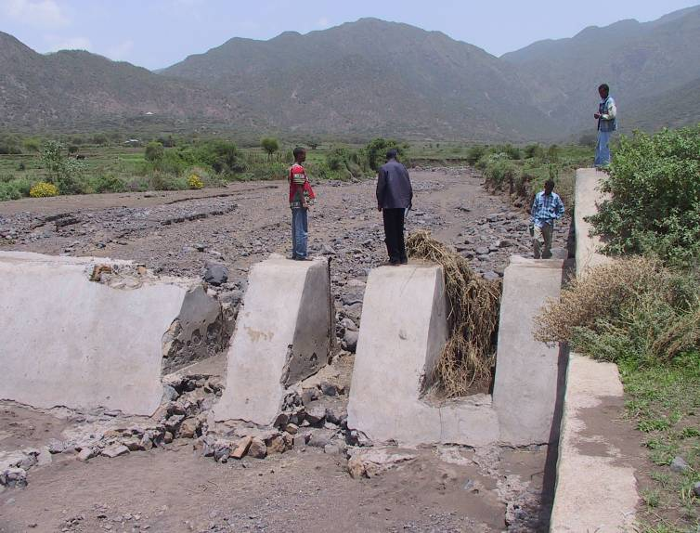

Figure 4: Provision of wider pier in front of the head regulator at Tirkie.
- turn out dimension, spacing and location,
- the wing walls at RCC flume crossing structure are not safe(they are scoured at some point),
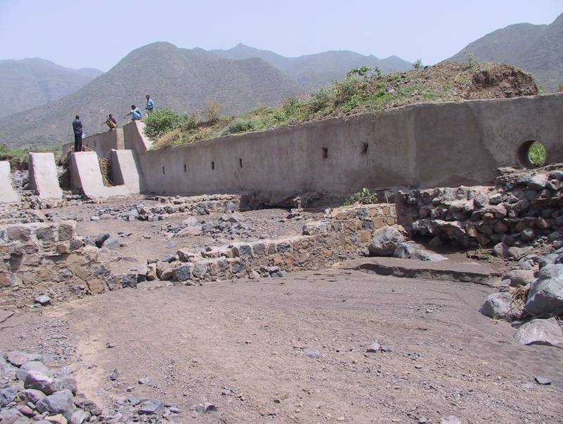

Figure 5: Side wall & D/S apron scouring at Tirkie.
CONSTRUCTION PROBLEMS
- difficulty to operate sluice gate due to poor construction procedures. The gate grooves are demolished at this moment for the gates can not be opened easily. The demolished part is not maintained yet. The farmers has blocked the sluice way instead by placing some alluvial deposit, stones/boulders and some vegetation in front of the sluice way.
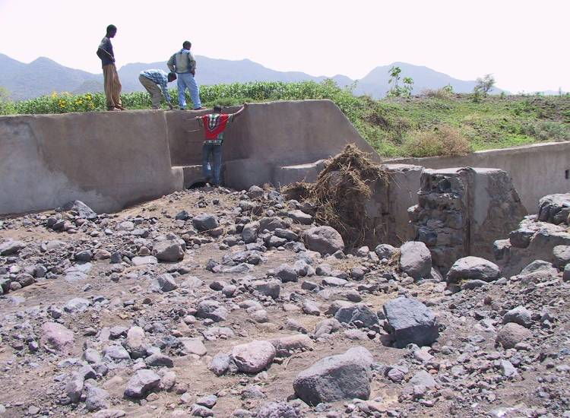

Figure 6: Blocked sluice gates at Tirkie.
- Poor construction of masonry structures especially at the D/S apron and slice way. This can be observed from the already eroded/scoured D/S impervious apron section just D/S of the sluice section. The stones for the masonry work are not bonded each other with good mortar (See Fig above)
OPERATIONAL PROBLEMS
- high sediment entry to the main offtaking canal due to poor sluice gate operation (see fig. ). The sediment load deposited in front of the head regulator can not be flushed out through the sluice way because the sluice gates are no more functional and the farmers has blocked the sluice ways with alluvial deposits, stones/boulders and vegetation.
- sediment entry to conveyance canal from the nearby cultivable area as ploughing is done till the edge of the canal top level (see fig. ),
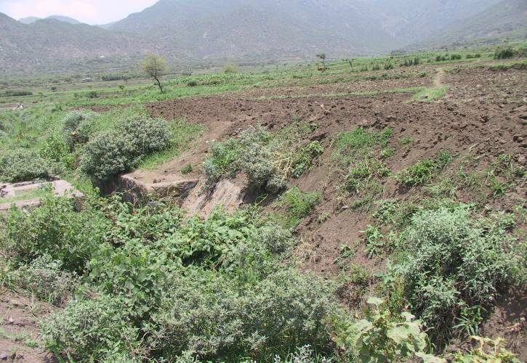

Figure 7: Sedimentation entry to canal from the nearby command area.
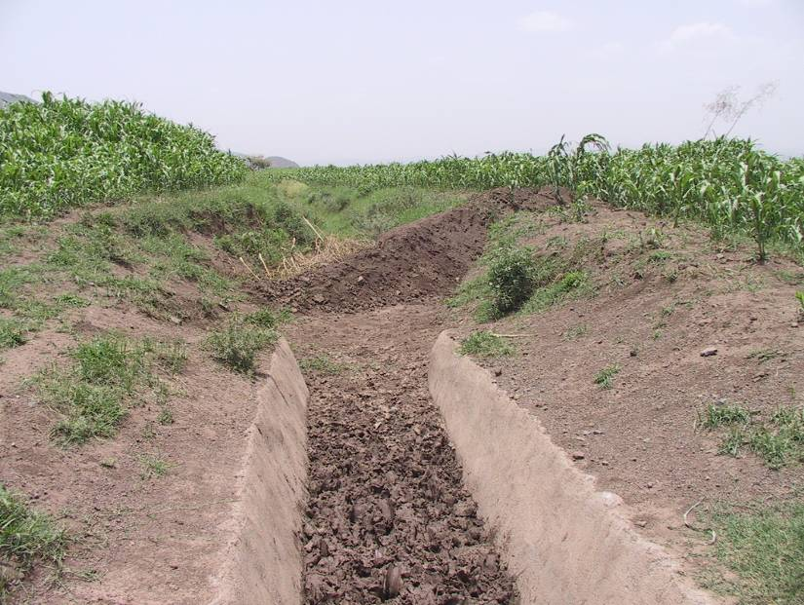
- breaching of main conveyance canal at some spots (see Fig. )

Figure 8: Breaching of the main canal at points where there is no turnout provision.

CLAIMS MADE BY THE FARMERS

- The designed offtake alignment is at right angle, on the other hand the farmers want the offtake to be aligned at some angle so that the diverted flow can enter the canal smoothly.
Figure 9: Rough sketch showing the offtake angle claimed by farmers at Tirkie
- the farmers want the offtake to be an open channel rather than pipe culverts,
- they want the sluice gates to be closed all the time so that any incoming runoff can be diverted without any wastage ( no wastage of runoff for flushing purpose),
- the flood duration is so short that (<2Hr.) the offtake should be large enough to pass through high runoff at a time.

3.3 BEYRU

The construction of this scheme is also completed in 1997EC. The scheme is not fully operational by the time the team visited the site. The offtake is made open channel, hopefully may be considering the interest of the farmers.
DESIGN PROBLEMS
- proper energy dissipation measure is not provided for flow that comes out of the de-silting basin flushing outlet & escape canal there.
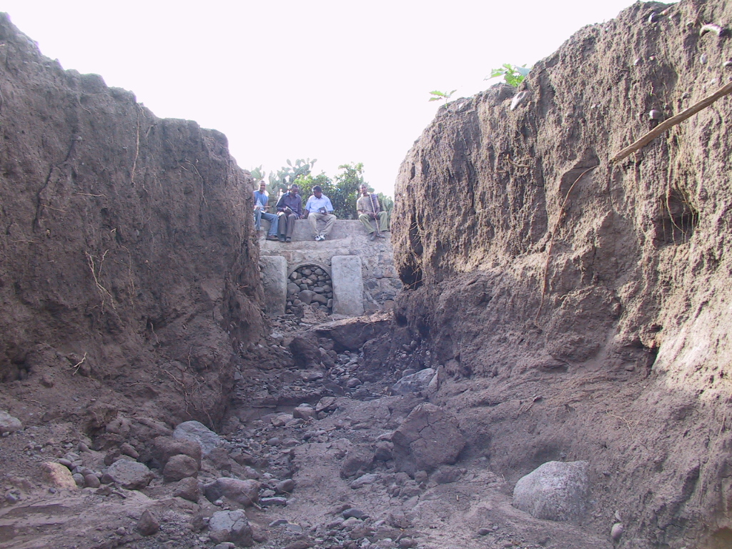
Escape canal

Flushing outlet pipe

Figure 10: Scouring around de-silting basin flushing outlet at Burka.
CONSTRUCTION PROBLEMS
- Gates (offtake, sluice and de-silting basin’s flushing outlet) not completed before the onset of the rainy season.
CLAIMS MADE BY THE FARMERS
- The offtake alignment here is at some angle, other than 90º, but the farmers want it to be at some angle lesser than the existing one.

The flow measured during the monitoring phase (4th of August, 1997EC) is found to be around 1.44m³/sec. This is the amount that passes through the main canal, though very little seeps through the sluice.

3.4 BURKA

The construction of this scheme is also completed in 1997EC. The scheme is not fully operational by the time the team visited the site. Here also an open channel offtake is provided. Though this helps to avoid clogging of offtake pipes by high sediment laden/boulder, the canal system may be susceptible for overtopping for the offtake gates may not be operated accordingly.

Besides a de-silting basin with good silt flushing provision is provided though no proper protection measure is provided for the channel that joins back to the river.

The flow measured during the monitoring phase (3rd of August, 1997EC) is found to be around 1.16m³/sec. This is the amount that passes through the main canal, though very little seeps through the sluice.

DESIGN PROBLEMS
- Side wall for main canal unable to with stand active earth pressure from the river side deposition and/or backfill material, for the whole wall depth (≈1.80m) is designed with 0.30m wall thickness. This may lead sooner to collapse of the wall.
- The foundation depth provided for the side wall of the main canal is not adequate enough to protect the structure against scouring for the wall foundation has been over hanged and then maintained by the farmers. For this regard, the side wall for some portion of the main canal, has collapsed during the construction phase by due to scouring and then maintained,
- The exit channel from the de-silting basin to the river is provided with no protection measures so that the adjoining river side command area is eroded and the bed for the exit channel is retrograted leading to the collapse of the basin sooner or later,

CONSTRUCTION PROBLEMS
- Gates are not provided for the sluice, offtake and de-silting basin’s flushing outlet on time. This leads to the wastage of some runoff from being diverted to the main canal. Even some of the diverted runoff to the main canal has been forced to flow back to the river through the de-silting basin’s flushing outlet. The number of generated runoff during the month of July is few, not more than two, and none of them can be harvested due to the above mentioned problem.

CLAIMS MADE BY THE FARMERS
- Here also the farmers complain that the offtake width and alignment and canal bottom width (for the main canal and division box) are not sufficient to pass the required runoff. The farmers had persistently complaining that the main canal width, which is 0.90m according to the design, is very narrow and forced some modification to be made (through discussion made with Woreda administration, Irrigation construction and irrigation study and design departments) on the main canal width. Accordingly the new canal bottom width has been widened to 2.20m though they are still complaining that this is still narrow as compared to the traditional canal bottom width, which is 3.50m. While the main canal is modified, nothing has been made to the sizes of the other conveyance canals in the system. They have been constructed according to the design.

4.0 CONCLUSION AND RECOMMENDATION

The regular maintenance of any irrigation scheme is vital for the longevity of the project. The Water Use Association is the eligible body that has to organize the beneficiaries or search for Funds to undertake maintenance works.

Measures to be taken

- Participating and entertaining the farmer’s idea during the study and construction phase. This makes the farmers feel the sense of ownership for the projects. It has been observed that in almost all of the schemes already constructed the farmers complain that they have raised some modification ideas during the construction phase, but none of them have been entertained. In areas like Raya valley where the farmers have been practicing spate irrigation for years and years, they have well developed knowledge of their environment. Therefore, allowing the farmers to participate during the study and construction phases of the projects has many benefits. Firstly, in the absence of recorded information, the farmers are the source of information. Secondly, the farmers will develop strong sense of ownership of the projects. This in turn will be good for healthy operation and maintenance of the projects.

In almost all of the schemes they complain about the angle of diversion, which is almost 90º, to be very much less than 90º. This need to be appreciated in the design procedures.

They need the head regulator to have an open channel offtake (the case of Burka and Beyru) in stead of pipe or box culvert (the case of Trkie and Hara). Though the latter has the advantage to control/limit the diverted runoff to the design capacity, the former can be safely provided with the provision of gates that can slide upwards. In fact, the structures are constructed in such a way that the sluice gates will be opened and the sediment trapped there flushed down. However, considering the existing moisture limitation the farmers are not willing to lose any drop of water. The farmers may consider any lose of flood through the structure as disruption of the traditional irrigation system.

- When considering traditional spate irrigation systems, it is provided with “wide” conveyance canals and “steep” canal bed slopes. The main as well as other canal networks in the case of traditional spate irrigation are wider than the upgraded spate irrigation system. These canal networks, as it has been observed, do not manifest any sign of silting nor scouring. On the other hand for the “upgraded” spate irrigation system, siltation is the main problem. This thereby calls for frequent canal maintenance unlike the traditional spate irrigation canal system.

In the case of Burka, the newly constructed canal systems seems very narrow that they might be easily blocked by some big boulders diverted from the main river, as there is no trash rack provided at the head regulator.

So, with regard to the construction of infrastructure, it seems better to use existing traditional spate irrigation canal networks as it is instead of designing a new canal network system.

- The other point that is worth noting is that maintaining the traditional water use systems highly crucial. The amount of flood to be harvested should not disrupt the traditional water use system. The flood to be harvested should not be lower than the demand of the upstream command area. At the same time the downstream users should be taken into account. Otherwise, it may end up creating water use conflict in the area. Especial example for this case is Burka. The users found at the right side (facing D/S) are complaining that they may not get enough water because of the constructed weir. So they have submitted their complaints to the Woreda administration. In fact, in the absence of flood it is difficult to prove or disprove their complaints. However, it gives good indications of such problems in the future.
- Traditional spate diversion headworks consume much energy, time and resource. It calls for frequent maintenance, needs use of huge amount of Acacia after end of each runoff event and lot of man power. A lot of acacia wood has to be cut down for constructing bunds reinforced with stones/boulders. These bunds have to be constructed at a number of different spots along a given reach each irrigating small amount of cultivable land. With this regard the design and construction of headworks in spate irrigation system avoids a lot of problems/inconvenience associated with the traditional system.

- When we think spate irrigation schemes, we should consider a design which can supplement the total command area at least once at a time. Since the coming runoff is not reliable we should not think of a design which supplements the command area on rotational basis. Taking the spate irrigation schemes we observed into consideration, there is a big time gap between two runoff events. So it will be impractical to think rotational irrigation on spate irrigation schemes unlike in river diversions in which there will be water all the time.

- It has been observed that the measured flow for Beyru & Burka irrigation schemes at the main canal is found to be 1.14m³/sec & 1.16m³/sec respectively. But it has been found that the farmers are going to irrigate the land in the usual way that has low application efficiency. Though this amount of diverted flow, according to the design, can irrigate approximately half of the design command area, it has been seen that this can not be achieved due to low application efficiency.

The runoff duration as observed in the case of Hara, has been found to stay for more than 8Hr., though the observed runoff is the one with very low return period; high probability of exceedence. So hard to say about the duration of the runoff produced from 1Yr. return period rainfall. In all of the sites observed the, the duration of the runoff with very small magnitude is high, more than 6Hr. from the inquire obtained from the local communities & from the field observation, it can be said that, surface runoff duration thereby the irrigation hour taken for most of the traditional spate upgrading design schemes (≈4.0Hr.) doesn’t have any problem
- Operation of sluice gates has created a problem in most of the schemes already constructed. Provision of screw lifted gates that can be operated at some platform might solve associated problems.

- In case of Hara, though the de-silting basin at the head regulator has got good sediment trapping efficiency, it has been observed that as the sediment laden is high the de-silting basin can not be cleaned manually. The beneficiaries can not clean the basin on daily basis as they are engaged on other farm activities. So provision of trash rack at the head entrance and some flushing out device on the De-silting basin using the diverted runoff will alleviate this problem.

- The Inverted Syphons should be provided with trash rack at the head entrance and manhole at some points so that clogging of the pipes can be avoided.

- Location and spacing of turnout structure should be adjusted in such a way that each beneficiary can irrigate without breaching the main conveyance canal (Hara and Tirkie)

- Location and spacing of tertiary canals should take existing land units into consideration (Tirkie). The scoured/eroded D/S impervious apron and D/S sidewall foundation should be maintained as soon as possible before the problem gets worsen.

- As the spate design procedures are some what conventional, information regarding the normal flood duration as obtained from local farmers has to be taken into account.

- Measure has to be taken to reduce or avoid the leakage through sluice gate grooves as sufficient driving head cannot be created at the sluice bay so as to divert the flow during low surface runoff (Hara).

- Since the sediment yield of the catchment area upstream of the weir sites are relatively high, soil and water conservation measures are needed so that the life of projects can be extended.
- Monitoring and evaluation works should be the mainstream in all project phases for the proper implementation and functionality of the projects.

- To avoid conflict among water users, water use policy should be obligatory.

- Operational problems are the main causes for the inefficient functionality of most of the projects. Proper operational trainings have to be provided for someone from the Water Use association or beneficiaries. The trainer has to show the trainees the how & when operation of especially the sluice gates during the rainy season.

